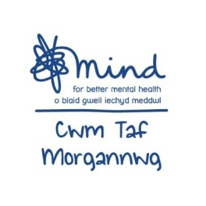
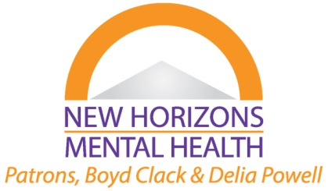
Cwm Taf Morgannwg
Recovery College Timetable- Autumn 2020
Course and Venue | Day |  | Time |  |  | Start Date | Weeks
CTM Mind- Online Courses/Workshops (Delivered on Zoom)
Confidence Building  (Agored Accredited) (14 Places) | Thursdays |  | 10.30am-12pm |  |  | 07/01/21 | 4
Understanding and Managing Depression  (14 Places) | Thursday |  | 1pm-2.30pm |  |  | 07/01/21 | 1
Mood and Food  (14 Spaces) | Friday |  | 10.30am-12pm |  |  | 08/01/21 | 1
Mental Health Awareness  (Agored Accredited) (14 Places) | Fridays |  | 1pm-2.30pm |  |  | 08/01/21 | 4
Manging Anger  (14 Places) | Thursday |  | 1pm-2.30pm |  |  | 14/01/21 | 1
Sleep Workshop  (14 Places) | Friday |  | 10.30am-12pm |  |  | 15/01/21 | 1
Understanding and Managing Anxiety  (14 Places) | Thursday |  | 1pm-2.30pm |  |  | 21/01/21 | 1
5 Ways to Wellbeing  (14 Places) | Friday |  | 10.30am-12pm |  |  | 22/01/21 | 1
Managing Covid Related Anxiety  (14 Places) | Thursday |  | 1pm-2.30pm |  |  | 28/01/21 | 1
Wellbeing and Resilience  (14 Places) | Friday |  | 10.30am-12pm |  |  | 29/01/21 | 1
Mood and Food  (14 Places) | Thursday |  | 10.30am-12pm |  |  | 04/02/21 | 1
New Horizons – Online Courses (Using Moodle & Microsoft Teams)

Managing Anxiety  (14 Places) |  | Tuesdays |  | 1.00pm – 3.00pm | 12/1/21 |  | 7
Stress Management  (14 Places) |  | Tuesdays |  | 6.00pm – 8.00pm | 12/1/21 |  | 5
Anger Management  (14 Places) |  | Wednesdays |  | 10.00am – 12.30pm | 13/1/21 |  | 7
Resilience Skills (14 Places) |  | Tuesdays |  | 9.30am – 12.00pm | 23/2/21 |  | 3
Mental Health & Wellbeing  (14 Places) |  | Tuesdays |  | 12.30pm – 3.00pm | 23/2/21 |  | 5
Managing Anxiety  (14 Places) |  | Tuesdays |  | 6.00pm – 8.00pm | 23/2/21 |  | 7
Managing Anxiety  (14 Places) |  | Wednesdays |  | 10.00am – 12.30pm | 3/3/21 |  | 7

New Horizons
16 Dean Street,
Aberdare, CF44 7BN
01685 881113
info@newhorizonsmentalhealth.co.uk
www.newhorizons-mentalhealth.co.uk

Cwm Taf Morgannwg Mind
115 High Street,
Merthyr Tydfil,
CF47 8AP
01685 707480 /707486
info@ctmmind.org.uk

